Poseidon

# Why Do you need this?

A typical Shooting Game will have hundreds of scattered projectiles and explosion particle systems that may slow down your game as not only the number of instantiated objects doesn’t have a ceiling; but as C# garbage collectors kick in at some point to clean up idle memory allocations causing a negative spike in the gameplay framerate.

*Poseidon* makes it easier for game programmers and designers to pool any game object regardless of its type

# Implementation

Download and Import from Unity Package Manager like any other asset.

Project Setup

1. In your Projects Window, Right click, Create, Poseidon and select GameObject pool

Projectile Object

1. Open any class component attached to your projectile game object and implement the IGameObjectPooled

interface It should add the line: public GameObjectPool Pool { get; set; }

1. Write your projectile end of life logic and at the point where the object is normally

destroyed, write: Pool?.ReturnToPool(this.gameObject);

Launching Object

1. In your projectile launching class:
   * get the Pool: [SerializeField] private GameObjectPool projectilePool;
   * Pre-Warm it: private void Awake() => projectilePool.PreWarm(); and
   * Shoot: var shot = projectilePool.Get();

Unity Editor

1. Back to unity Interface:
   * drag the projectile GameObject to your project folder to create a prefab
   * Select the pool scriptable object from your project folder and drag the projectile prefab to the GameObjectPool field in the inspector
   * Select the launching GameObject and drag the pool scriptable object to the ProjectilePool field in the.

Steps are illustrated on the next page. Watch the [tutorial video](https://youtu.be/OXeLo7Kc_-4?t=55) if you need to or refer to the two Demo scenes included.

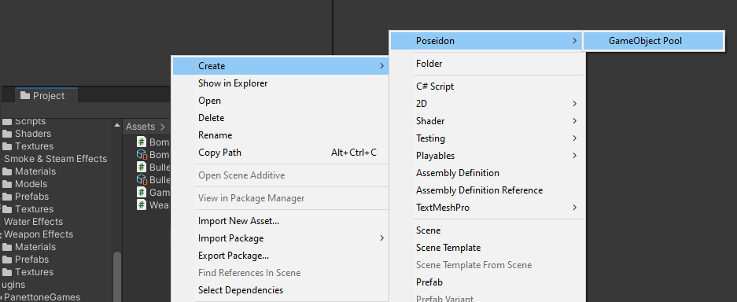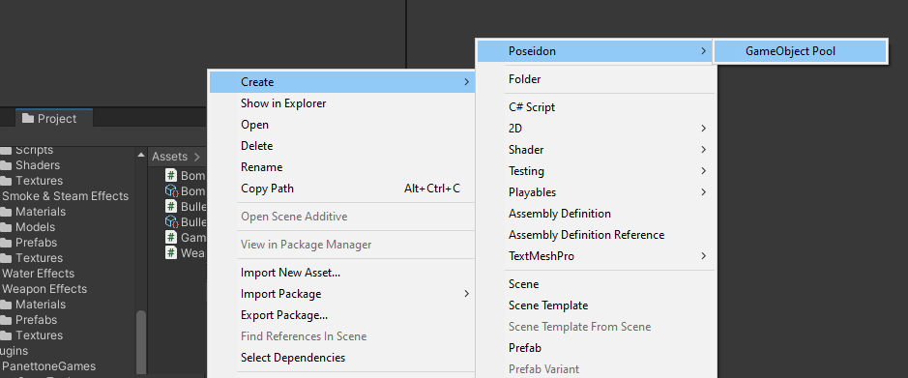

Create the pool

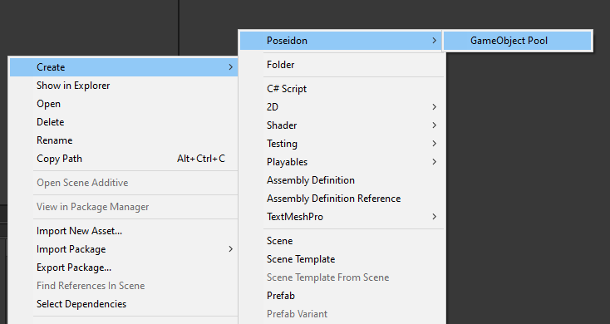

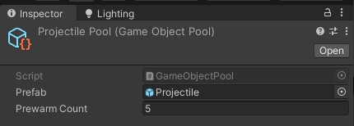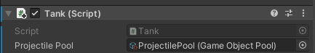

Step 1

Implements IGameObjectPooled

Step 2

A Prefab of the Object containing Projectile Class (from previous step)

Step 3

The Pool (from previous step)

Alternatively, you can set up a standard game object from the menus

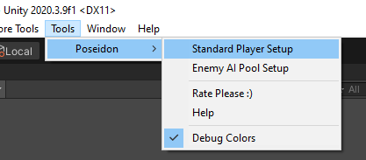

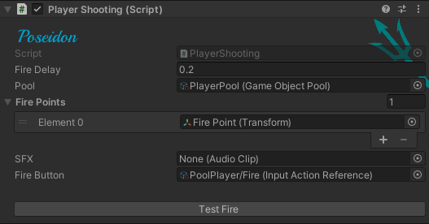

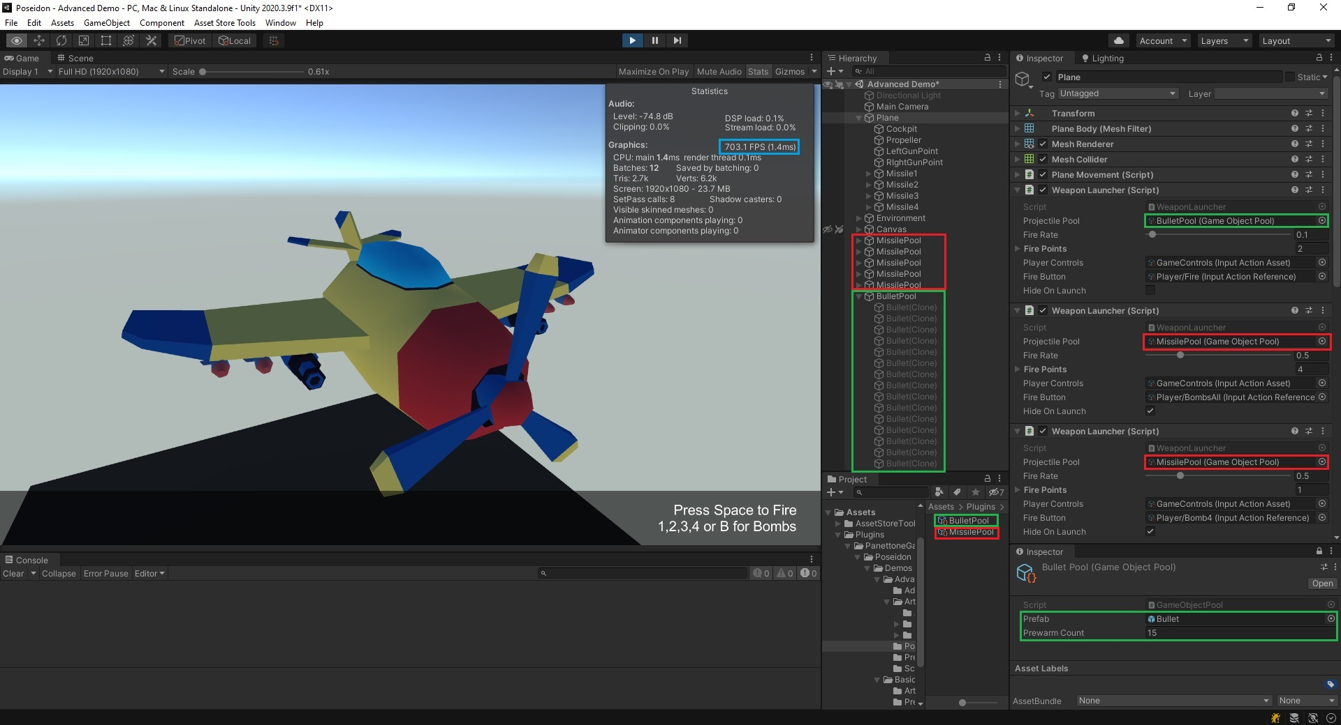

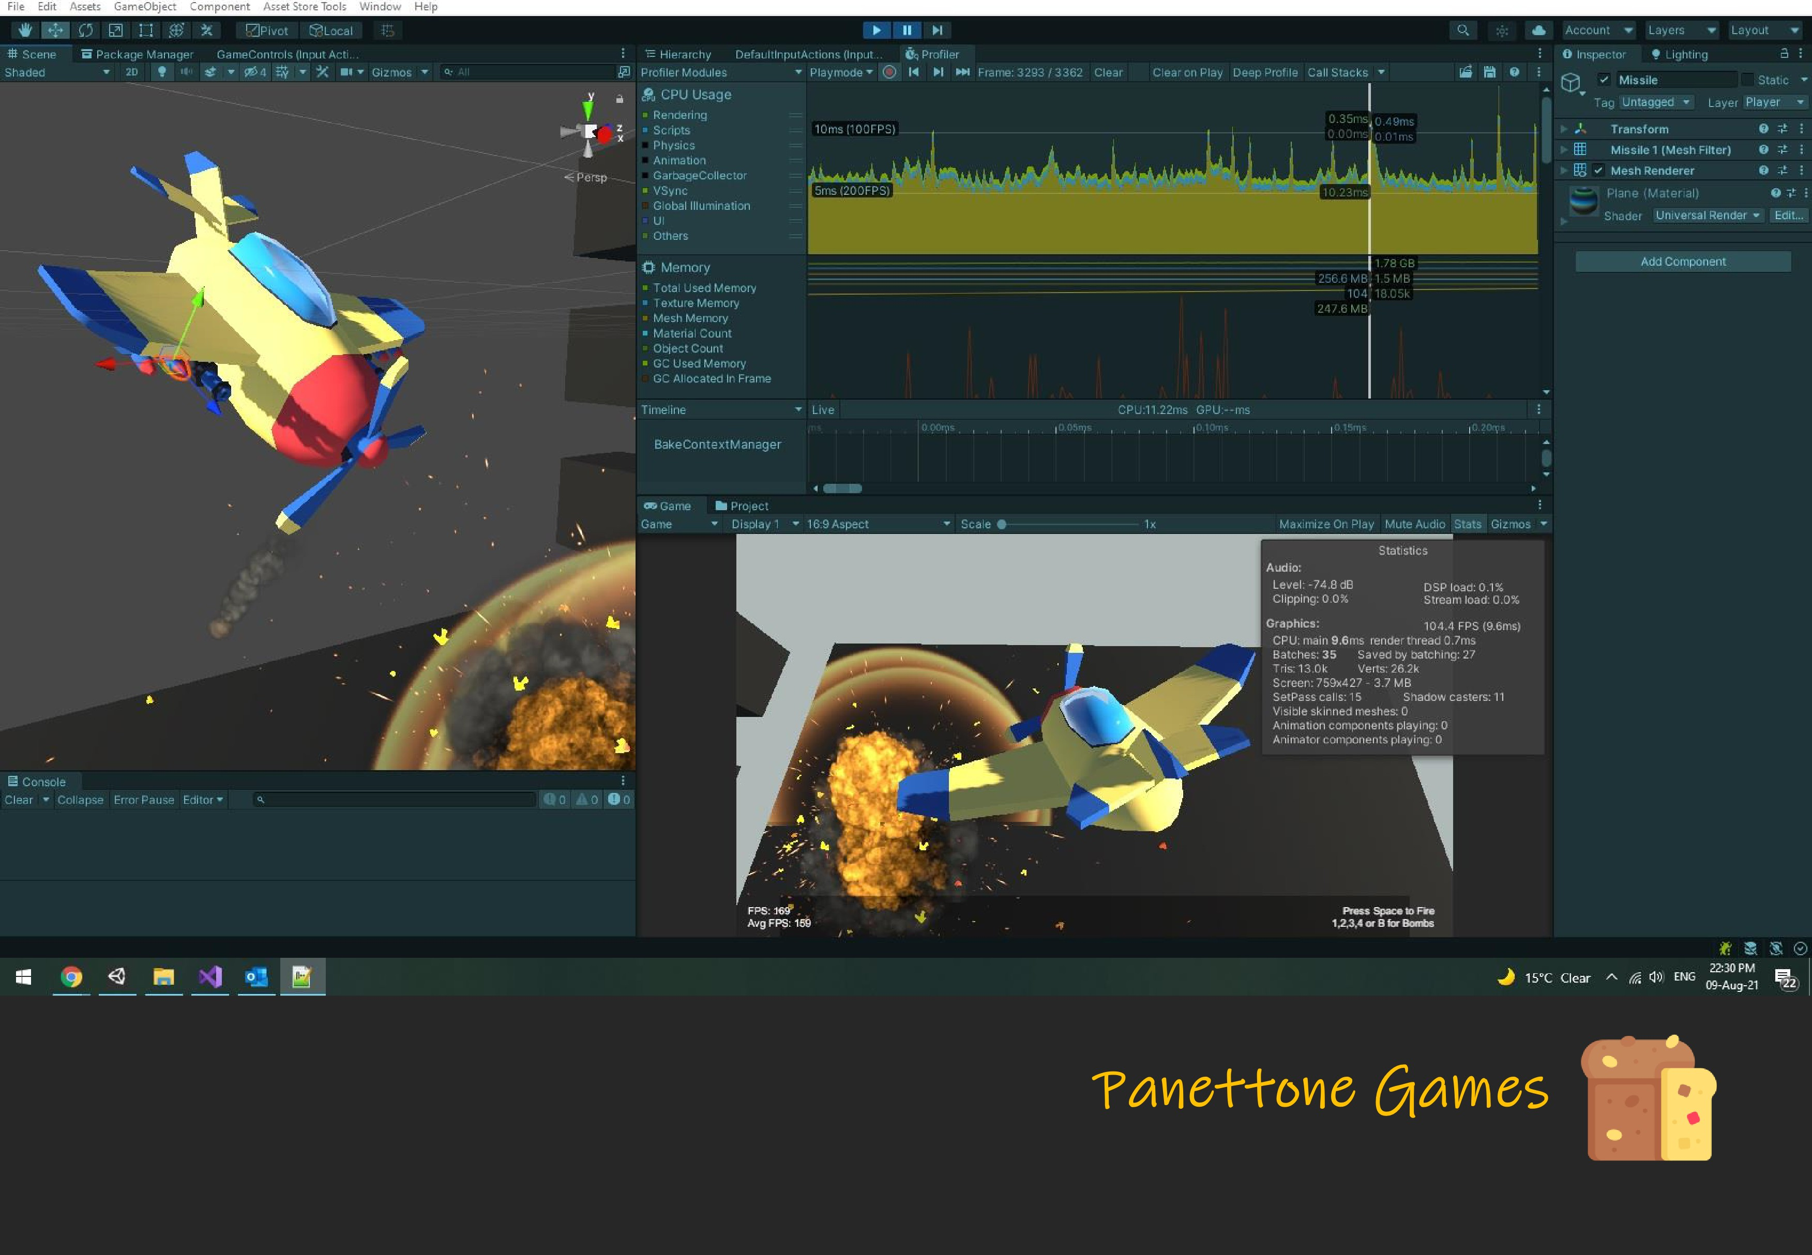

[*Productivity Tools for Game Developers*](https://panettonegames.com/)